Metro Area Analysis Findings

* Metro Area Methodology
  + Used US Census data to define metro areas
  + Metro Areas that were researched are identified by counties which make up both Combined Statistical Areas (which contain a Metropolitan Area) and individual Metropolitan Areas
    - Combined Statistical Area (CSA): a group of adjacent Metro/Micropolitan Cities with economic/social ties measured by commuting patterns – eg: Los Angeles-Long Beach, CA; New York-Newark, NY-NJ-CT-PA
    - Metropolitan Area: a region with a population of at least 50,000 and close economic ties within the area that is encompassed – eg: Tallahassee, FL; Baton Rouge
  + In other words, CSA’s that include at least one Metropolitan Area and Metropolitan Areas that are not included within a CSA are identified as Metro Areas in this analysis
* Top Metro Areas
  + Recruiting Count

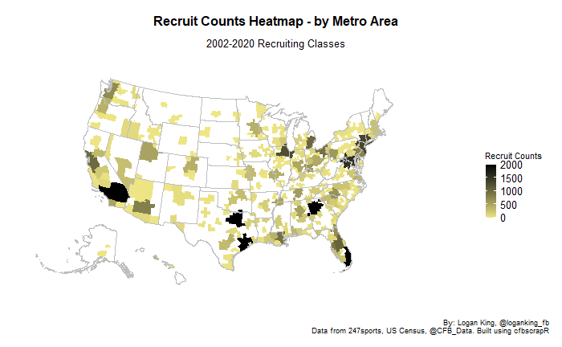

* + NFL Players

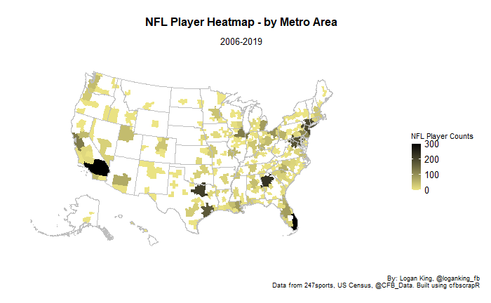

* + Vanderbilt Commit Count

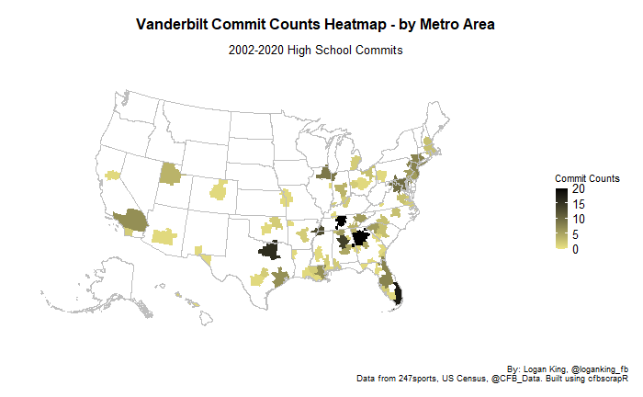

* Success/Failure
  + Top Success %

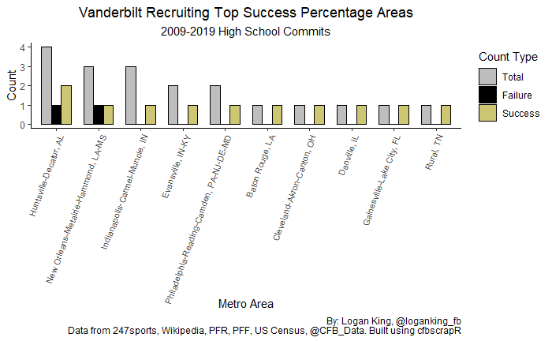

* + Top Failure %

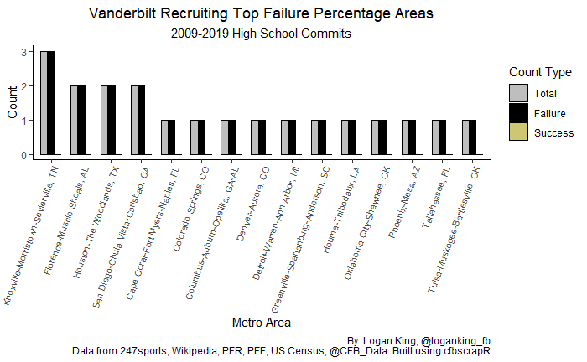

* College-NFL
  + More NFL players come from rural areas than any single urban area for the period observed
  + Metro Area players rising at both levels compared to rural area players – at college level potentially due to location of recruiting combines; at both levels potentially due to definition of metro-area (50,000), as more locations are becoming defined as metro areas with population growth
  + Talent Proportion by Metro Area

